### Use Case Diagram

**The Figure 7.1** Represents a Use Case Diagram for an Expense Management Website it illustrates the interaction between the User (Actor) and the system's functionalities.

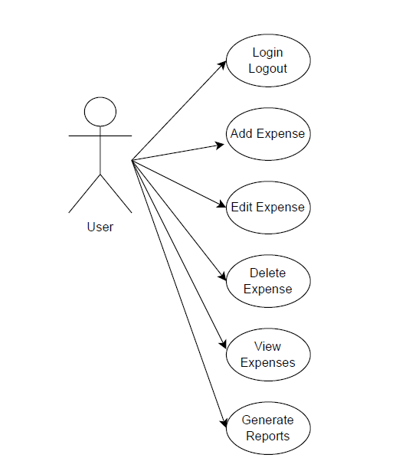

**Figure 7.1: Use Case diagram of system**